Chi-squared Hypothesis Testing

# Chi-squared Tests

## Goodness of Fit

### Example 1

Use the Chi-squared test to investigate if the observed data is different from the predicted data

* i For a normal distribution with mean 170cm and mean 10cm

|  |  |  |
| --- | --- | --- |
| Bins | Observed | Expected |
| <160 | 3 | 2.4 |
| 160-170 | 3 | 5.1 |
| 170-180 | 7 | 5.1 |
| 180- | 2 | 2.4 |

## geom_path: Each group consists of only one observation. Do you need to  
## adjust the group aesthetic?

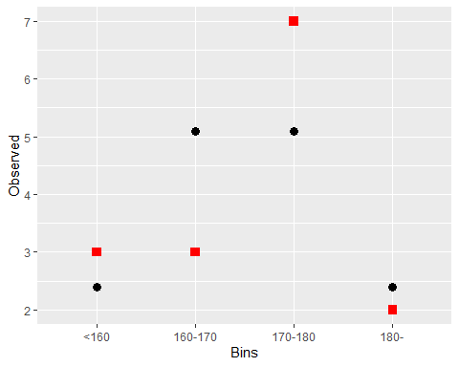

##   
## Chi-squared test for given probabilities  
##   
## data: Observed  
## X-squared = 1.7892, df = 3, p-value = 0.6173

* ii For a flat distribution

|  |  |  |
| --- | --- | --- |
| Bins | Observed | Expected |
| <160 | 3 | 3.75 |
| 160-170 | 3 | 3.75 |
| 170-180 | 7 | 3.75 |
| 180- | 2 | 3.75 |

##   
## Chi-squared test for given probabilities  
##   
## data: Observed  
## X-squared = 3.9333, df = 3, p-value = 0.2688

## Test of Independence

An ice-cream company had 500 people sample one of three different ice-cream flavours and asked them to say whether they liked or disliked the ice-cream. The resulting observed data is presented in the table below

## Vanilla Chocolate Strawberry  
## Liked 130 170 100  
## Disliked 20 30 50

Conduct a hypothesis test to determine if these data supply evidence (alpha = 0.05) that the enjoyment of the ice-cream depends on the flavour

##   
## Pearson's Chi-squared test  
##   
## data: Icecream  
## X-squared = 23.958, df = 2, p-value = 6.274e-06

